Assignment 1|Day 1

**1. Print 'Hello' and Your Name**

**Write a Java program to print 'Hello' on the screen and then print your name on a separate line.**

**Expected Output:**

**Hello**

**Alexandra Abramov**

**Program:**

**public class HelloWorld {**

**public static void main(String[] args) {**

**System.out.println("Hello");**

**System.out.println("Ankita Durgude");**

**}**

**}**

**Output:**

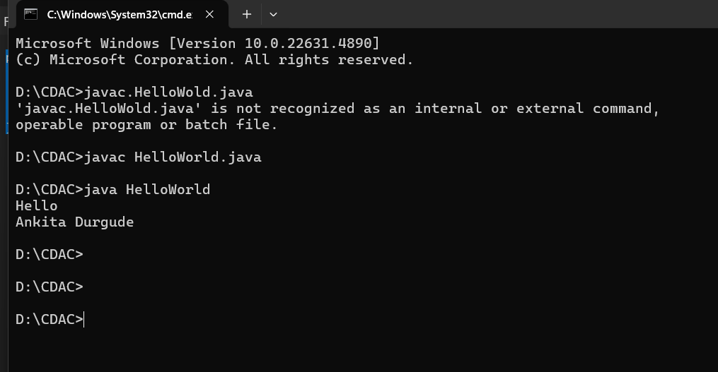

**2. Sum of Two Numbers**

**Write a Java program to print the sum of two numbers.**

**Test Data: 74 + 36**

**Expected Output:**

**110**

Program:

public class SumOfTwoNumbers {

public static void main(String[] args) {

int num1 = 10;

int num2 = 20;

int sum = num1 + num2;

System.out.println("Sum of " + num1 + " and " + num2 + " is: " + sum);

}

}

Output:

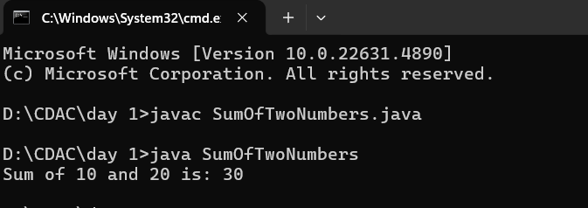

Program 1:

ArithmeticOperations

public class ArithmeticOperations {

public static void main(String[] args) {

int result1 = -5 + 8 * 6; // a

int result2 = (55 + 9) % 9; // b

int result3 = 20 + -3 * 5 / 8; // c

int result4 = 5 + 15 / 3 * 2 - 8 % 3; // d

System.out.println("Result of -5 + 8 * 6: " + result1);

System.out.println("Result of (55 + 9) % 9: " + result2);

System.out.println("Result of 20 + -3 * 5 / 8: " + result3);

System.out.println("Result of 5 + 15 / 3 * 2 - 8 % 3: " + result4);

}

}

Output:

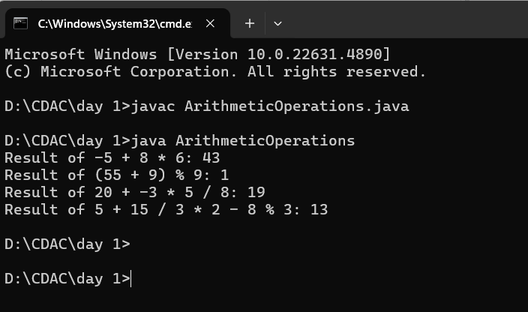

Program 2: **Multiply Two Numbers**

**Write a Java program that takes two numbers as input and displays the product of the two numbers.**

**Test Data:**

• **Input first number: 25**

• **Input second number: 5**

**Expected Output:**

**25 x 5 = 125**

Program 2:

import java.util.Scanner;

public class MultiplyTwoNumbers {

public static void main(String[] args) {

Scanner scanner = new Scanner(System.in);

System.out.print("Input first number: ");

int firstNumber = scanner.nextInt();

System.out.print("Input second number: ");

int secondNumber = scanner.nextInt();

int product = firstNumber * secondNumber;

System.out.println(firstNumber + " x " + secondNumber + " = " + product);

scanner.close();

}

}

Output:

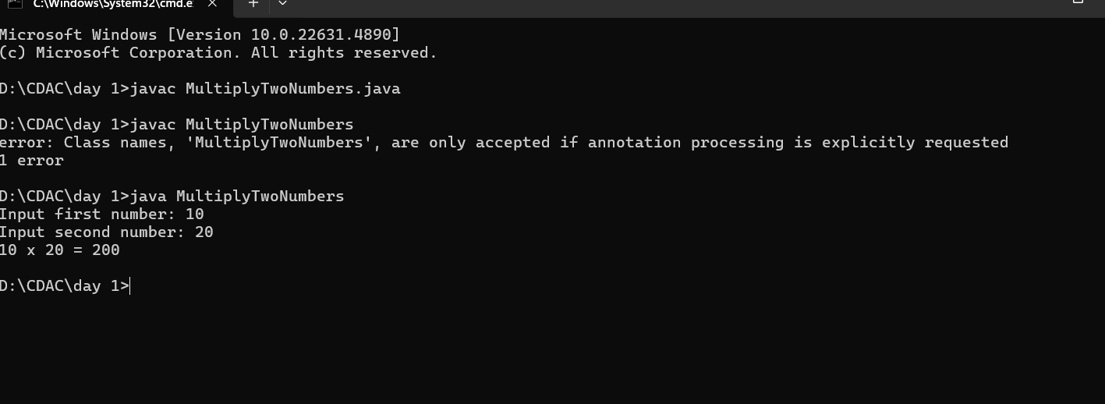

**3. Divide Two Numbers**

**Write a Java program to divide two numbers and print the result on the screen.**

**Test Data: 50 / 3**

**Expected Output:**

**16**

**Program:**

public class Division {

public static void main(String[] args) {

int numerator = 50;

int denominator = 2;

int quotient = numerator / denominator;

int remainder = numerator % denominator;

System.out.println("Quotient: " + quotient);

System.out.println("Remainder: " + remainder);

}

}

Output:

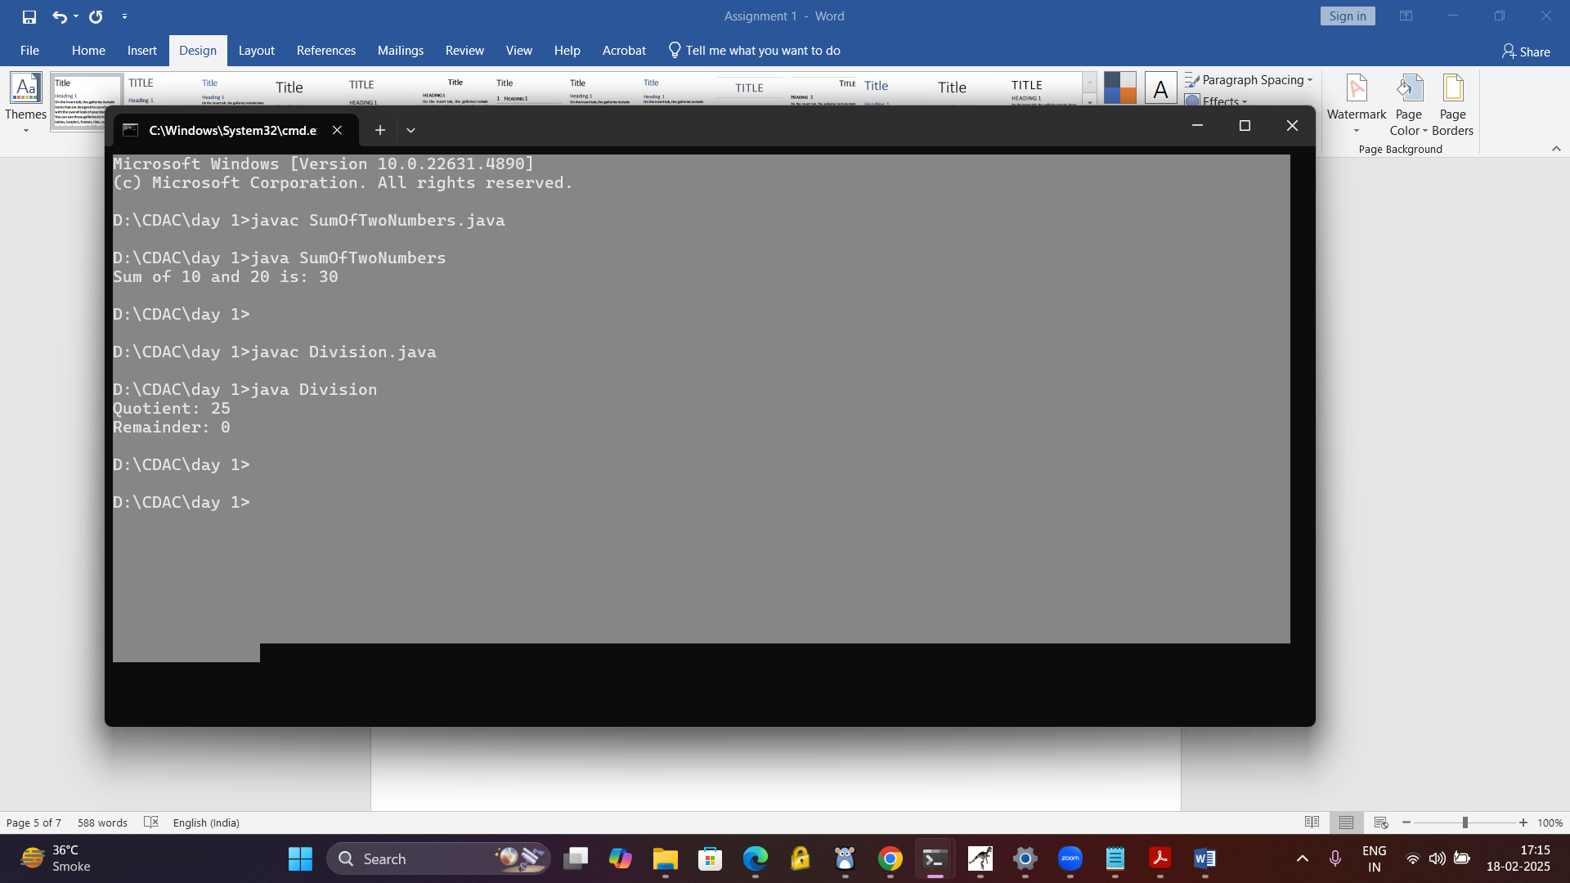

**6. Basic Arithmetic Operations**

**Write a Java program to print the sum, multiplication, subtraction, division, and remainder of two numbers.**

**Test Data:**

• **Input first number: 125**

• **Input second number: 24**

**Expected Output:**

**125 + 24 = 149**

**125 - 24 = 101**

**125 x 24 = 3000**

**125 / 24 = 5**

**125 mod 24 = 5**

**Program:**

import java.util.Scanner;

public class BasicArithmeticOperations {

public static void main(String[] args) {

Scanner scanner = new Scanner(System.in);

System.out.print("Input first number: ");

int firstNumber = scanner.nextInt();

System.out.print("Input second number: ");

int secondNumber = scanner.nextInt();

int sum = firstNumber + secondNumber;

int difference = firstNumber - secondNumber;

int product = firstNumber * secondNumber;

int quotient = firstNumber / secondNumber;

int remainder = firstNumber % secondNumber;

System.out.println(firstNumber + " + " + secondNumber + " = " + sum);

System.out.println(firstNumber + " - " + secondNumber + " = " + difference);

System.out.println(firstNumber + " x " + secondNumber + " = " + product);

System.out.println(firstNumber + " / " + secondNumber + " = " + quotient);

System.out.println(firstNumber + " mod " + secondNumber + " = " + remainder);

scanner.close();

}

}

Output:

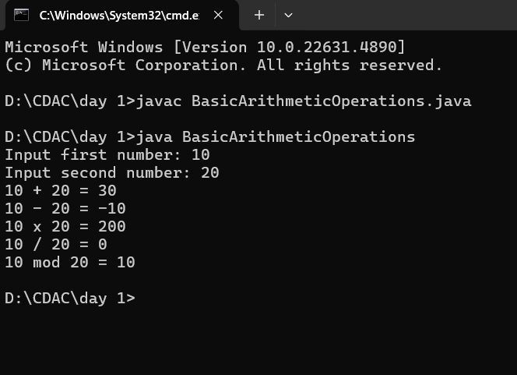

**5. Multiply Two Numbers**

**Write a Java program that takes two numbers as input and displays the product of the two numbers.**

**Test Data:**

• **Input first number: 25**

• **Input second number: 5**

**Expected Output:**

**25 x 5 = 125**

Program:

import java.util.Scanner;

public class MultiplyTwoNumbers {

public static void main(String[] args) {

// Create a Scanner object to take input from the user

Scanner scanner = new Scanner(System.in);

// Ask the user for the first number

System.out.print("Input first number: ");

int firstNumber = scanner.nextInt();

// Ask the user for the second number

System.out.print("Input second number: ");

int secondNumber = scanner.nextInt();

// Calculate the product of the two numbers

int product = firstNumber * secondNumber;

// Display the result

System.out.println(firstNumber + " x " + secondNumber + " = " + product);

// Close the scanner to prevent resource leak

scanner.close();

}

}

Output:

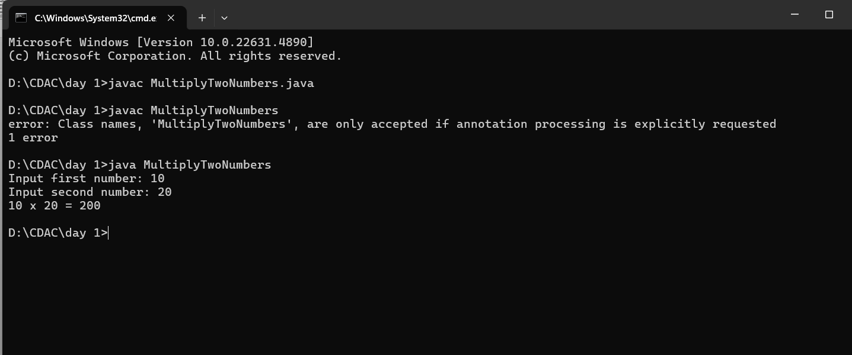

**6. Basic Arithmetic Operations**

**Write a Java program to print the sum, multiplication, subtraction, division, and remainder of two numbers.**

**Test Data:**

• **Input first number: 125**

• **Input second number: 24**

**Expected Output:**

**125 + 24 = 149**

**125 - 24 = 101**

**125 x 24 = 3000**

**125 / 24 = 5**

**125 mod 24 = 5**

Program:

import java.util.Scanner;

public class BasicArithmeticOperations {

public static void main(String[] args) {

Scanner scanner = new Scanner(System.in);

System.out.print("Input first number: ");

int firstNumber = scanner.nextInt();

System.out.print("Input second number: ");

int secondNumber = scanner.nextInt();

int sum = firstNumber + secondNumber;

int difference = firstNumber - secondNumber;

int product = firstNumber * secondNumber;

int quotient = firstNumber / secondNumber;

int remainder = firstNumber % secondNumber;

System.out.println(firstNumber + " + " + secondNumber + " = " + sum);

System.out.println(firstNumber + " - " + secondNumber + " = " + difference);

System.out.println(firstNumber + " x " + secondNumber + " = " + product);

System.out.println(firstNumber + " / " + secondNumber + " = " + quotient);

System.out.println(firstNumber + " mod " + secondNumber + " = " + remainder);

scanner.close();

}

}

Output:

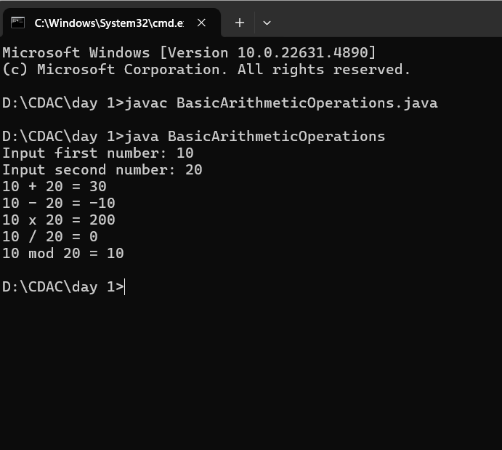

**7. Multiplication Table**

**Write a Java program that takes a number as input and prints its multiplication table up to 10.**

**Test Data:**

• **Input a number: 8**

**Expected Output:**

**8 x 1 = 8**

**8 x 2 = 16**

**8 x 3 = 24**

**8 x 4 = 32**

**8 x 5 = 40**

**8 x 6 = 48**

**8 x 7 = 56**

**8 x 8 = 64**

**8 x 9 = 72**

**8 x 10 = 80**

Program:

import java.util.Scanner;

public class MultiplicationTable {

public static void main(String[] args) {

Scanner scanner = new Scanner(System.in);

System.out.print("Input a number: ");

int number = scanner.nextInt();

for (int i = 1; i <= 10; i++) {

int result = number * i;

System.out.println(number + " x " + i + " = " + result);

}

scanner.close();

}

}

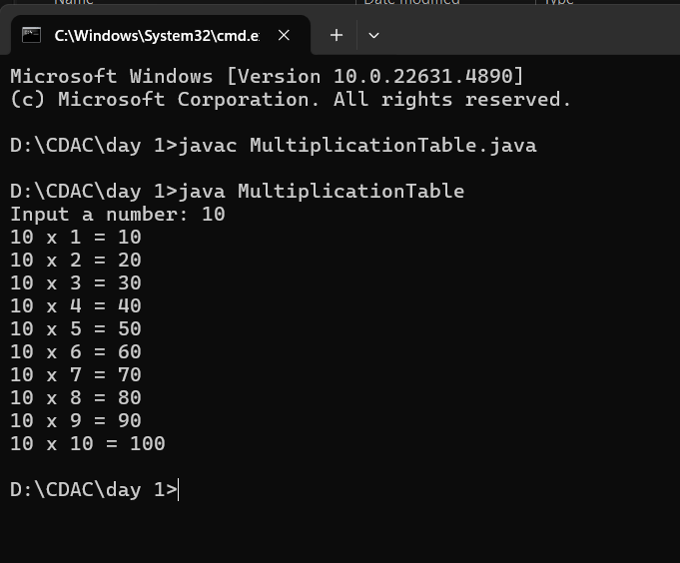

**8. Swap Two Numbers**

**Write a Java program to swap the values of two variables without using a third variable.**

**Test Data:**

• **Input first number: 10**

• **Input second number: 20**

**Expected Output:**

**Before swapping:**

First number:10

**Second number: 20**

**After swapping:**

**First number: 20**

**Second number: 10**

Output:

import java.util.Scanner;

public class SwapTwoNumbers {

public static void main(String[] args) {

Scanner scanner = new Scanner(System.in);

System.out.print("Input first number: ");

int firstNumber = scanner.nextInt();

System.out.print("Input second number: ");

int secondNumber = scanner.nextInt();

System.out.println("Before swapping:");

System.out.println("First number: " + firstNumber);

System.out.println("Second number: " + secondNumber);

firstNumber = firstNumber + secondNumber;

secondNumber = firstNumber - secondNumber;

firstNumber = firstNumber - secondNumber;

System.out.println("After swapping:");

System.out.println("First number: " + firstNumber);

System.out.println("Second number: " + secondNumber);

scanner.close();

}

}

Output:

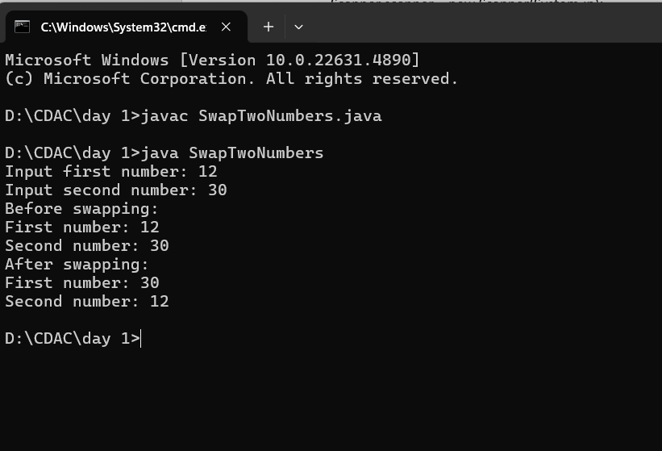

**9. Calculate the Area of a Circle**

**Write a Java program that calculates the area of a circle.**

**Test Data:**

• **Input the radius: 7**

**Formula: Area = π * radius²**

**Expected Output:**

**Area of the circle: 153.93804**

Program:

import java.util.Scanner;

public class CircleArea {

public static void main(String[] args) {

Scanner scanner = new Scanner(System.in);

System.out.print("Input the radius: ");

double radius = scanner.nextDouble();

double area = Math.PI * radius * radius;

System.out.println("Area of the circle: " + area);

scanner.close();

}

}

Output:

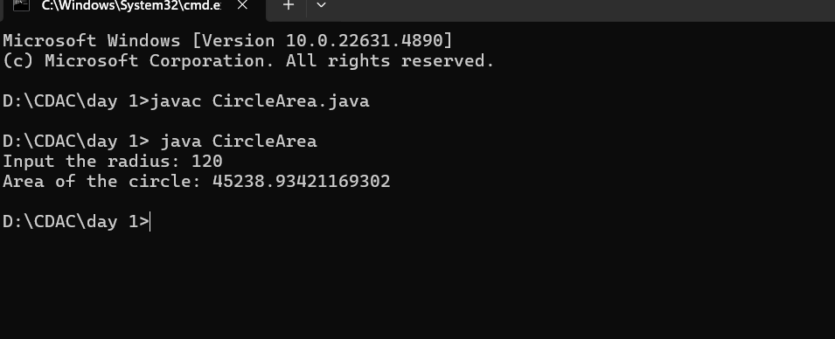

**10. Check If a Number Is Even or Odd**

**Write a Java program that checks if a number is even or odd.**

**Test Data:**

• **Input a number: 15**

**Expected Output:**

**The number 15 is Odd.**

Program:

import java.util.Scanner;

public class EvenOddCheck {

public static void main(String[] args) {

Scanner scanner = new Scanner(System.in);

System.out.print("Input a number: ");

int number = scanner.nextInt();

if (number % 2 == 0) {

System.out.println("The number " + number + " is Even.");

} else {

System.out.println("The number " + number + " is Odd.");

}

scanner.close();

}

}

Output:

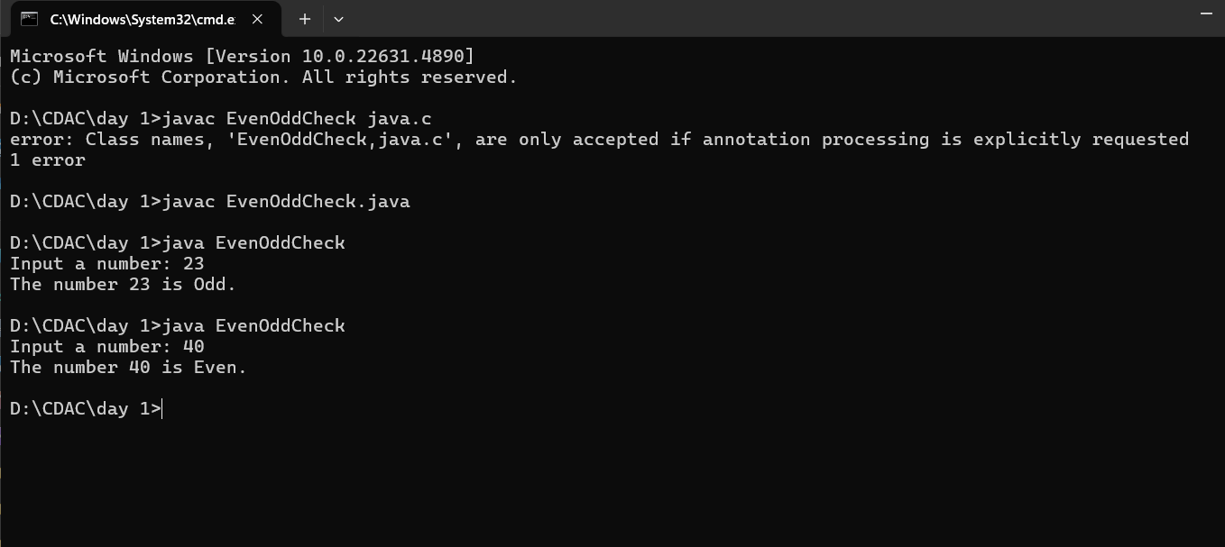

**11. Find the Largest of Three Numbers**

**Write a Java program that takes three numbers as input and finds the largest of the three.**

**Test Data:**

• **Input first number: 12**

• **Input second number: 45**

Program:

import java.util.Scanner;

public class LargestOfThreeNumbers {

public static void main(String[] args) {

// Create a Scanner object to read input from the user

Scanner scanner = new Scanner(System.in);

// Ask the user for the first number

System.out.print("Input first number: ");

int firstNumber = scanner.nextInt();

System.out.print("Input second number: ");

int secondNumber = scanner.nextInt();

System.out.print("Input third number: ");

int thirdNumber = scanner.nextInt();

int largest = firstNumber;

if (secondNumber > largest)

{

largest = secondNumber;

}

if (thirdNumber > largest) {

largest = thirdNumber;

}

System.out.println("The largest number is: " + largest);

scanner.close();

}

}

Output:

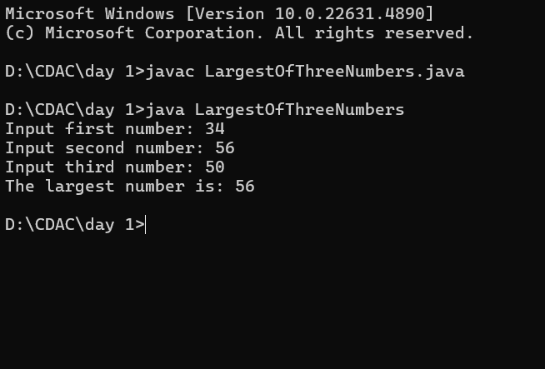

**12. Reverse a Number**

**Write a Java program that takes a number as input and prints the reverse of that number.**

**Test Data:**

• **Input number: 12345**

**Expected Output:**

**The reverse of 12345 is 54321.**

import java.util.Scanner;

public class ReverseNumber {

public static void main(String[] args) {

Scanner scanner = new Scanner(System.in);

System.out.print("Input number: ");

int number = scanner.nextInt();

int reverse = 0;

while (number != 0) {

int digit = number % 10;

reverse = reverse * 10 + digit;

number = number / 10; }

System.out.println("The reverse of the number is: " + reverse);

scanner.close();

}

}

Output:

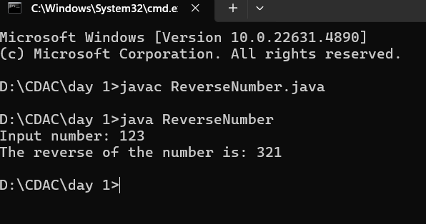

**13. Calculate the Average of Three Numbers**

**Write a Java program to calculate the average of three numbers.**

**Test Data:**

• **Input first number: 20**

• **Input second number: 40**

• **Input third number: 60**

**Expected Output:**

**The average**

Program:

import java.util.Scanner;

public class AverageOfThreeNumbers {

public static void main(String[] args) {

Scanner scanner = new Scanner(System.in);

System.out.print("Input first number: ");

int firstNumber = scanner.nextInt();

System.out.print("Input second number: ");

int secondNumber = scanner.nextInt();

System.out.print("Input third number: ");

int thirdNumber = scanner.nextInt();

double average = (firstNumber + secondNumber + thirdNumber) / 3.0;

System.out.println("The average is: " + average);

scanner.close();

}

}

Otput:

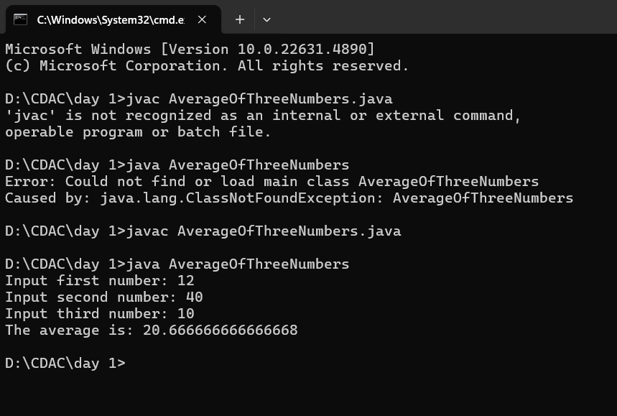

**14. Print the Fibonacci Series**

**Write a Java program to print the Fibonacci series up to the 10th number.**

**Expected Output:**

**0 1 1 2 3 5 8 13 21 34**

Program:

public class FibonacciSeries {

public static void main(String[] args) {

int n = 10;

int first = 0, second = 1;

System.out.print("Fibonacci Series up to " + n + " terms: ");

for (int i = 1; i <= n; i++) {

System.out.print(first + " ");

int next = first + second;

first = second;

second = next;

}

}

}

Output:

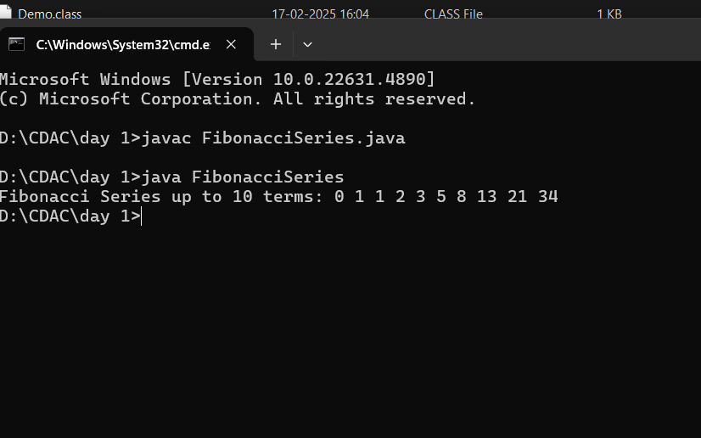

**15. Find the Factorial of a Number**

**Write a Java program to find the factorial of a number.**

**Test Data:**

• **Input a number: 5**

**Expected Output:**

**Factorial of 5 is 120.**

Program:

import java.util.Scanner;

public class Factorial {

public static void main(String[] args) {

Scanner scanner = new Scanner(System.in);

System.out.print("Input a number: ");

int number = scanner.nextInt();

long factorial = 1;

for (int i = 1; i <= number; i++) {

factorial *= i; // Multiply factorial by i for each iteration

}

System.out.println("Factorial of " + number + " is " + factorial);

}

}

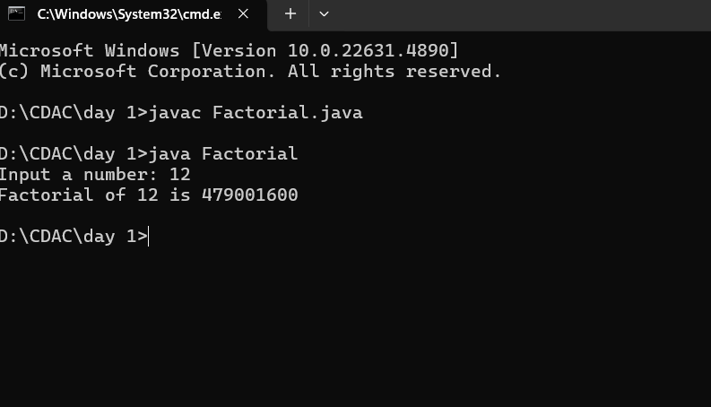

**16. Check Whether a Number Is Prime**

**Write a Java program to check whether a number is prime or not.**

**Test Data:**

• **Input number: 17**

**Expected Output:**

**The number 17 is Prime.**

Program:

import java.util.Scanner;

public class PrimeCheck {

public static void main(String[] args) {

Scanner scanner = new Scanner(System.in);

System.out.print("Input number: ");

int number = scanner.nextInt();

boolean isPrime = true;

if (number <= 1) {

isPrime = false;

} else {

for (int i = 2; i <= Math.sqrt(number); i++) {

if (number % i == 0) {

isPrime = false;

break;

}

}

}

if (is Prime) {

System.out.println("The number " + number + " is Prime.");

} else {

System.out.println("The number " + number + " is not Prime.");

}

}

}

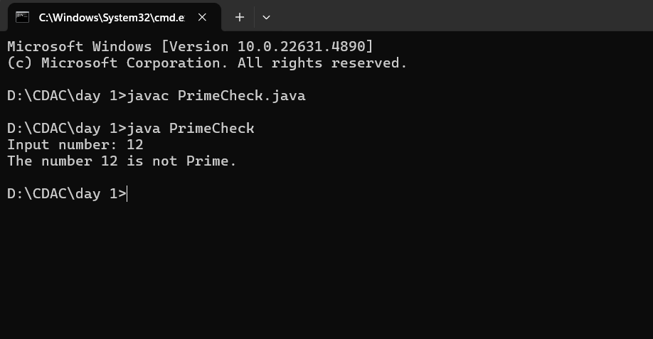

**17. Print the First N Natural Numbers**

**Write a Java program to print the first N natural numbers, where N is provided by the user.**

**Test Data:**

• **Input a number: 6**

**Expected Output:**

**1 2 3 4 5 6**

Program:

import java.util.Scanner;

public class NaturalNumbers {

public static void main(String[] args) {

Scanner scanner = new Scanner(System.in);

System.out.print("Input a number: ");

int N = scanner.nextInt();

System.out.print("First " + N + " natural numbers: ");

for (int i = 1; i <= N; i++) {

System.out.print(i + " ");

}

}

}

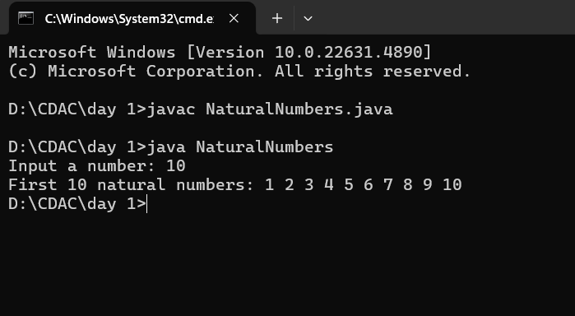

**18. Convert Celsius to Fahrenheit**

**Write a Java program to convert a temperature from Celsius to Fahrenheit.**

**Test Data:**

• **Input temperature in Celsius: 25**

**Formula: Fahrenheit = (Celsius * 9/5) + 32**

**Expected Output:**

**25°C is equal to 77.0°F**

Program:

import java.util.Scanner;

public class CelsiusToFahrenheit {

public static void main(String[] args) {

Scanner scanner = new Scanner(System.in);

System.out.print("Input temperature in Celsius: ");

double celsius = scanner.nextDouble();

double fahrenheit = (celsius * 9 / 5) + 32;

System.out.printf("%.1f°C is equal to %.1f°F\n", celsius, fahrenheit);

}

}

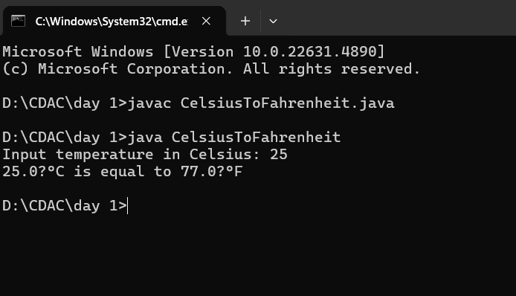

**19. Calculate the Power of a Number**

**Write a Java program that calculates the power of a number. Take two numbers as input: the base and the exponent, and compute the result of base raised to the power of exponent.**

**Test Data:**

• **Input base number: 3**

• **Input exponent number: 4**

**Expected Output:**

**3 raised to the power 4 is 81**

Program:

import java.util.Scanner;

public class PowerOfNumber {

public static void main(String[] args) {

Scanner scanner = new Scanner(System.in);

System.out.print("Input base number: ");

int base = scanner.nextInt();

System.out.print("Input exponent number: ");

int exponent = scanner.nextInt();

double result = Math.pow(base, exponent);

System.out.println(base + " raised to the power " + exponent + " is " + (int)result);

}

}

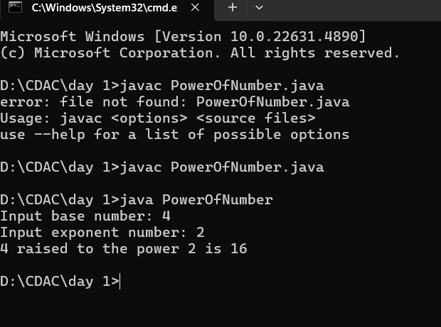

**20. Count the Number of Digits in a Number**

**Write a Java program that counts the number of digits in a given number.**

**Test Data:**

• **Input number: 123456**

**Expected Output:**

**The number 123456 has 6 digits.**

import java.util.Scanner;

public class CountDigits {

public static void main(String[] args) {

Scanner scanner = new Scanner(System.in);

System.out.print("Input number: ");

int number = scanner.nextInt();

int digitCount = 0;

if (number == 0) {

digitCount = 1;

} else {

while (number != 0) {

number /= 10;

digitCount++;

}

}

System.out.println("The number has " + digitCount + " digits.");

}

}

